New Branching Strategy Guidelines - Platform

2015
Table of Contents
Executive Summary 2
New Branching Strategy 3
Key Features of the New Branching Strategy 4
1. Easily Identifiable and Traceable Branches 4
2. Strict Branching Rules for Code Quality and Stability 4
3. Risk Reduction & Parallel Development 5
How the Branching Strategy Works 5
A. Single Source of Truth – The main Branch 5
B. Development Workflow 5
Handling Hotfixes 7
Branch Protection Rules 8
1. Main branch protection: 8
2. Develop branch protection: 8
3. Release branch protection: 8
4. Protected Branches 8
Branch Validation for New Branch Creation 8
1. Feature Branch (feature/<JIRA-ID>-<short-description>): 8
2. Hotfix Branch (hotfix/JIRA-ID-short-description): 8
3. Release Branch (release/x.y.z): 8
4. Automated validation (Git hooks or CI/CD) should enforce: 8
Roles & Responsibilities 9
Benefits of the New Branching Strategy 9
• Improved Traceability 9
• Minimized Merge Conflicts 9
• Faster Releases & Minimal Code Freeze 9
• Parallel Development & Risk-Free Releases 9
• Cleaner & More Organized Codebase 9
Conclusion 9

Executive Summary
The new branching strategy aims to establish a structured and efficient workflow that improves traceability, minimizes merge conflicts, ensures clean release branches, and eliminates unnecessary delay because of code freezes. By introducing standardized branch naming conventions, clear separation of feature development, and controlled integration processes, the new strategy will enhance collaboration, streamline releases, and maintain code stability while allowing continuous development.

New Branching Strategy
The proposed branching strategy is designed to enhance traceability, stability, and efficiency in the software development lifecycle while minimizing merge conflicts and code freezes. It follows a structured approach where every branch serves a specific purpose, ensuring controlled feature progression from development to production.

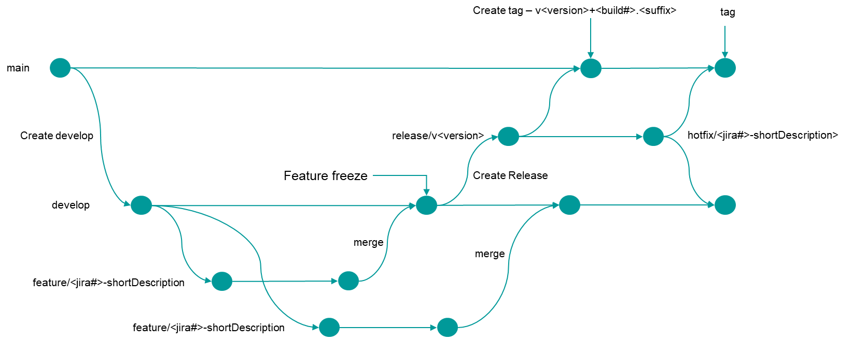

The proposed branching strategy is influenced with one of popular branching strategy GitFlow, It is a branching strategy for Git that helps manage development workflows efficiently. It introduces a structured approach with the following key branches:
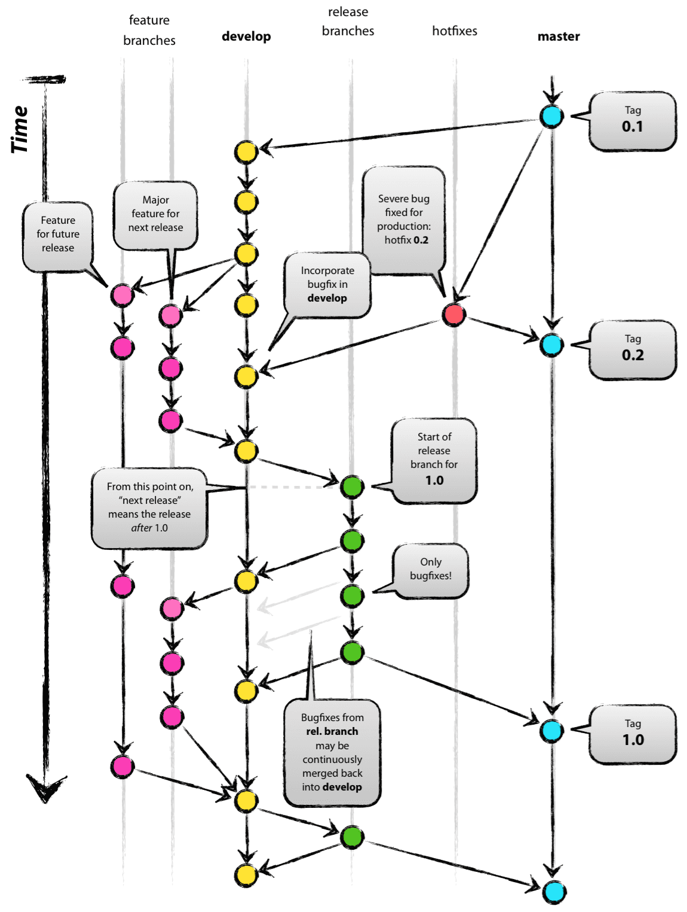
- Main (or Master) – The stable production branch containing only released code.
- Develop – The integration branch where feature branches are merged before release.
- Feature Branches – Used for developing new features; branched from develop and merged back when complete.
- Release Branches – Created from develop to prepare for a new production release, allowing final bug fixes and versioning before merging into main and develop.
- Hotfix Branches – Used for urgent fixes on main; branched from main and merged back into both main and develop.
GitFlow helps streamline version control, improve collaboration, and ensure a structured release process. GitFlow is popular among product development teams due to its clear separation of concerns, structured release process, and strong support for parallel feature development. It is robust for projects with scheduled releases.

Key Features of the New Branching Strategy

Easily Identifiable and Traceable Branches
  - Clear separation of release branches and feature branches.
  - Feature branches are linked to JIRA user stories/epics for traceability.
  - GitLab integrations allow navigation between JIRA tickets and feature branches.

Strict Branching Rules for Code Quality and Stability
  - No direct commits to main or develop branches.
  - Feature development always happens in a dedicated feature branch.
  - Releases are instantaneous, avoiding long code freezes.

Risk Reduction & Parallel Development
  - Release branches are protected from contamination by ongoing feature development.
  - Hotfixes are handled separately and merged into both main and develop to maintain consistency.
  - Developers can continue working on features without affecting the release branch.

How the Branching Strategy Works

A. Single Source of Truth – The main Branch
- The main branch (Sacred Branch) serves as the final, stable version of the code.
- It is only updated after successful releases.
- It is always in sync with the latest production-ready code.

B. Development Workflow

Creating a Development Branch (develop)
  - The develop branch is created from main and remains in sync.
  - This is where feature branches are merged after development.

Feature Branches (feature/JIRA-ID-short-description)
  - Developers create feature branches from develop.
  - Each feature branch follows a naming convention:
feature/<JIRA-ID>-<short-description>
  - No direct commits to develop or main.
  - When a feature is complete, it is merged into develop.
  - Lifecycle of feature is complete
    - Feature branch creation (feature/<JIRA-ID>-<short-description>) from Develop.
    - Development and testing within the feature branch.
    - Code review & approvals via merge request (MR).
    - Feature merged back into develop (once tested and approved).
    - Release branch is created, incorporating the feature.
    - Final QA testing in the release branch before production.
    - Deployment to production (once merged into main).

Feature Freeze and Release Branch Creation (release/x.y.z)
  - Once a feature is ready for release, the Product Owner (PO) calls a feature freeze.
  - A release branch is created from develop at the frozen commit.
  - The naming follows existing semantic versioning:
release/x.y.z (e.g., release/1.2.0).
  - The release branch is deployed in test and higher environments.
  - Start Feature Freeze:
    - When Feature has completed DoD criteria and passed all Quality Check Gates
    - When the release branch is created from develop.
    - No new features should be merged into develop after this point.
    - Only bug fixes, refinements, and final testing occur before release.
  - End Feature Freeze:
    - After the release branch has been thoroughly tested, all critical bugs are resolved, and the release is ready for production.
    - PO should approve the end of the feature freeze once the release meets the DoD and quality criteria.
    - When the release branch is merged into main and tagged for production.
    - Feature development resumes in develop after the release is complete.
  - Bug Fix in Release Branch Before Going to Production
    - Bug fixes should be directly committed to the release branch (release/x.y.z).
    - After fixing:
      - Merge the release branch into main and tag it for deployment.
      - Merge back into develop to ensure future releases include the fix.
    - If a critical fix is needed after deployment, create a hotfix branch from main.

Continued Feature Development While Release Testing
  - Developers continue working on new features in separate branches without impacting the release.
  - This avoids delays due to long code freezes.

Merging Release to main and Tagging the Version
  - Once testing is complete, the release branch is merged into main.
  - A version tag (x.y.z) is added to the main branch for tracking.
  - The release branch is also merged into develop to keep it up to date.
  - A release can be tagged (vX.Y.Z) only if:
    - All features & bug fixes in the release branch are tested and stable.
    - CI/CD pipelines pass all automated tests (unit, integration, security).
    - Product Owner (PO) & QA teams approve the release.
    - No critical open issues or blockers exist.
    - Security & performance checks are complete.

Handling Hotfixes
- If a critical issue is found after the production release, a hotfix branch is created from the release branch.
- The hotfix branch follows a naming convention:
hotfix/JIRA-ID-short-description
- The fix is first applied to the release branch and deployed.
- Then, it is merged into both main (with a new version tag) and develop branches to ensure all branches stay in sync.

Branch Protection Rules
To maintain stability and avoid accidental deletions, enforce these rules:

1. Main branch protection:
- No direct commits (only allow merge requests).
- Require 1 or 2 approvals before merging.
- CI/CD checks must pass before allowing merge.

2. Develop branch protection:
- No direct commits, only merges from feature branches.
- PRs require review & approval before merging.
- Unit tests and SonarQube gates must pass before merging.

3. Release branch protection:
- No direct commits except critical bug fixes.
- Merge allowed only from develop (to start a release) and into main (for deployment).

4. Protected Branches
- No branch deletion for main, develop, and release branches.

Branch Validation for New Branch Creation
1. Feature Branch (feature/<JIRA-ID>-<short-description>):
- Must be created from develop.
- Naming must follow feature/<JIRA-ID>-<short-description> format.
2. Hotfix Branch (hotfix/JIRA-ID-short-description):
- Must be created from main for urgent bug fixes.
- Must be merged into both main & develop after completion.
3. Release Branch (release/x.y.z):
- Must be created from develop only when feature freeze starts.
- Only bug fixes & documentation updates allowed.

4. Automated validation (Git hooks or CI/CD) should enforce:
- Proper naming conventions.
- No direct commits to protected branches.
- Merge rules & required approvals.

Roles & Responsibilities

Benefits of the New Branching Strategy
- Improved Traceability – Features and hotfixes are linked to JIRA tickets, making tracking easy.
- Minimized Merge Conflicts – Feature branches are separate, and releases are isolated.
- Faster Releases & Minimal Code Freeze – Code freezes last only a few hours instead of days.
- Parallel Development & Risk-Free Releases – Developers can continue working on new features without affecting the release.
- Cleaner & More Organized Codebase – Prevents release contamination, ensuring stable production code.

Conclusion
This strategy ensures efficient collaboration, faster releases, and stable production deployments while maintaining strict traceability and quality control.

